
OMBASA ISAAC OMOKE
BSCCS/2024/53672
Bachelor of Science in Computer Science
Unit Code: BIT3208
Unit Name: Advanced Web Design and Development
Lecturer Name: Michael Nyoro
Project Details: School Management System (SMS)
Selected Technologies:
XAMPP — local server environment (Apache + MySQL + PHP)
PHP 8.0.30 — server-side scripting language
MySQL — relational database management system
phpMyAdmin — graphical interface for managing MySQL databases
Microsoft Edge — browser for testing localhost

Online Portifolio / Github Link:
https://github.com/Isaac-Y67

Contents
WEEK 6: Database Integration and CRUD Operations 2
Evidence 2
Reflection 6
WEEK 7: Database Integration and CRUD Operations 7
Evidence 7
Reflection 13

Figure 1: sms_db database structure showing all 10 tables with row counts confirming complete database integration 2
Figure 2: students table Structure tab showing columns, data types and foreign key relationships 2
Figure 3: SQL SELECT JOIN query retrieving student records joined with users and classes tables 3
Figure 4: Add student form showing all input fields with validation — personal, guardian and account sections 3
Figure 5: Green flash message confirming new student record was inserted into the database 4
Figure 6: Students list page displaying all records retrieved from the database with search and pagination 4
Figure 7: Edit student form pre-populated with existing student data ready for update 5
Figure 8: Green flash message confirming the student record was updated in the database 5
Figure 9: JavaScript confirmation dialog appearing before deactivating a student account 5
Figure 10: GitHub repository showing Week 6 source code, database script and screenshots uploaded 6
Figure 11: Registration page showing full name, email, student number, phone and password fields with strength checker 7
Figure 12: users table Browse tab showing bcrypt hashed passwords confirming passwords are never stored as plain text 8
Figure 13: SMS login page showing email field, password field with show/hide toggle and login button 8
Figure 14: Successful admin login redirecting to admin dashboard confirming session creation 9
Figure 15: PHP session variables showing user_id, user_name and user_role stored after login 9
Figure 16: Browser redirected to login page when attempting to access dashboard without being logged in 10
Figure 17: Admin dashboard accessible only to admin role showing sidebar, stat cards and charts 10
Figure 18: Teacher dashboard accessible only to teacher role showing assigned courses and marks chart 11
Figure 19: Student dashboard accessible only to student role showing grades and attendance bars 11
Figure 20: Login page shown after logout confirming the session was destroyed 12
Figure 21: GitHub repository showing Week 7 source code, database script and screenshots uploaded 12

WEEK 6: Database Integration and CRUD Operations

Evidence

Figure 1: sms_db database structure showing all 10 tables with row counts confirming complete database integration
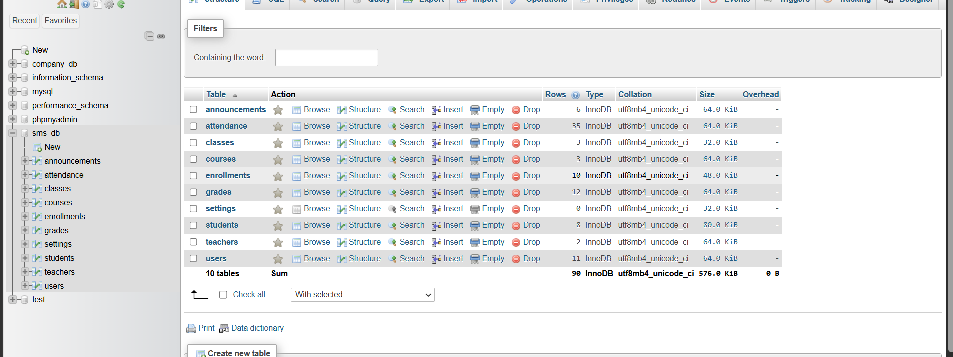

Figure 2: students table Structure tab showing columns, data types and foreign key relationships
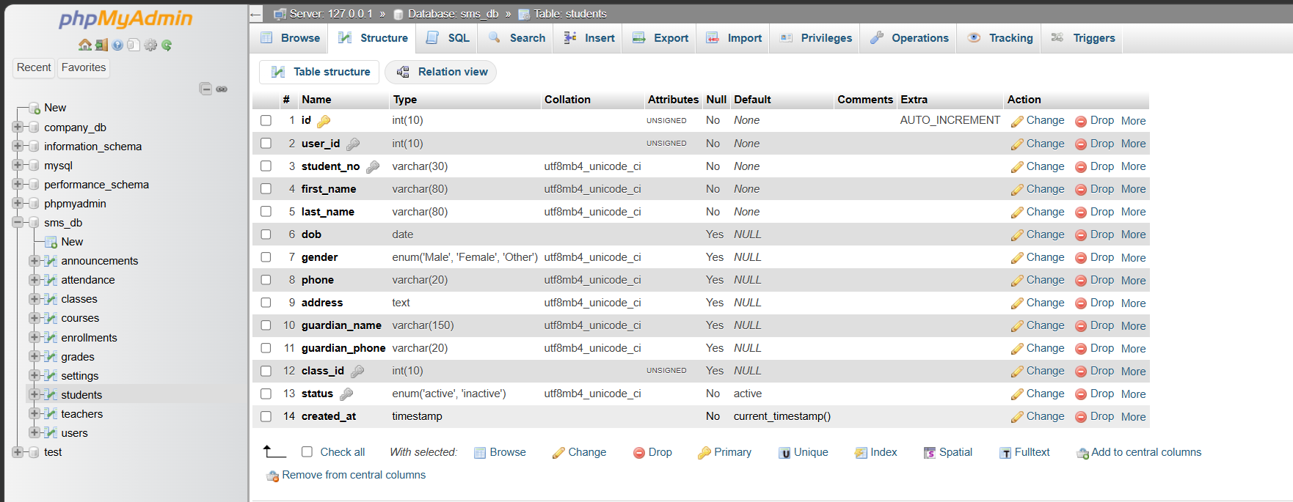

Figure 3: SQL SELECT JOIN query retrieving student records joined with users and classes tables
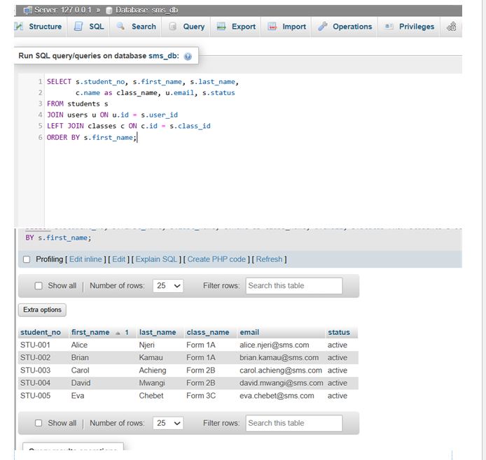

Figure 4: Add student form showing all input fields with validation — personal, guardian and account sections
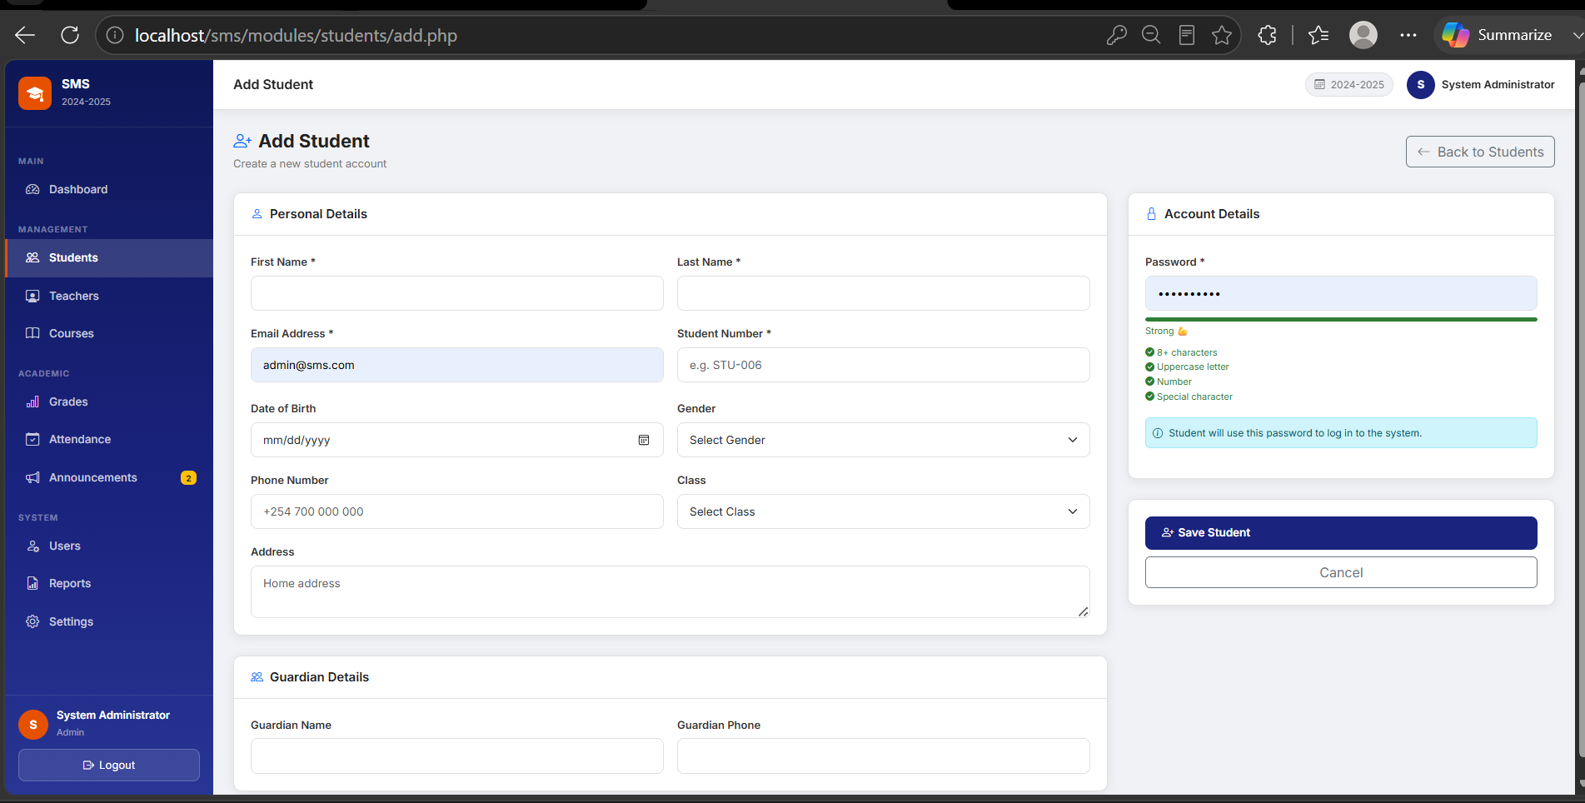

Figure 5: Green flash message confirming new student record was inserted into the database
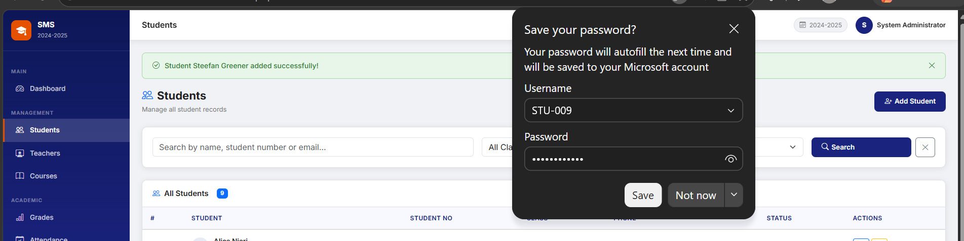

Figure 6: Students list page displaying all records retrieved from the database with search and pagination
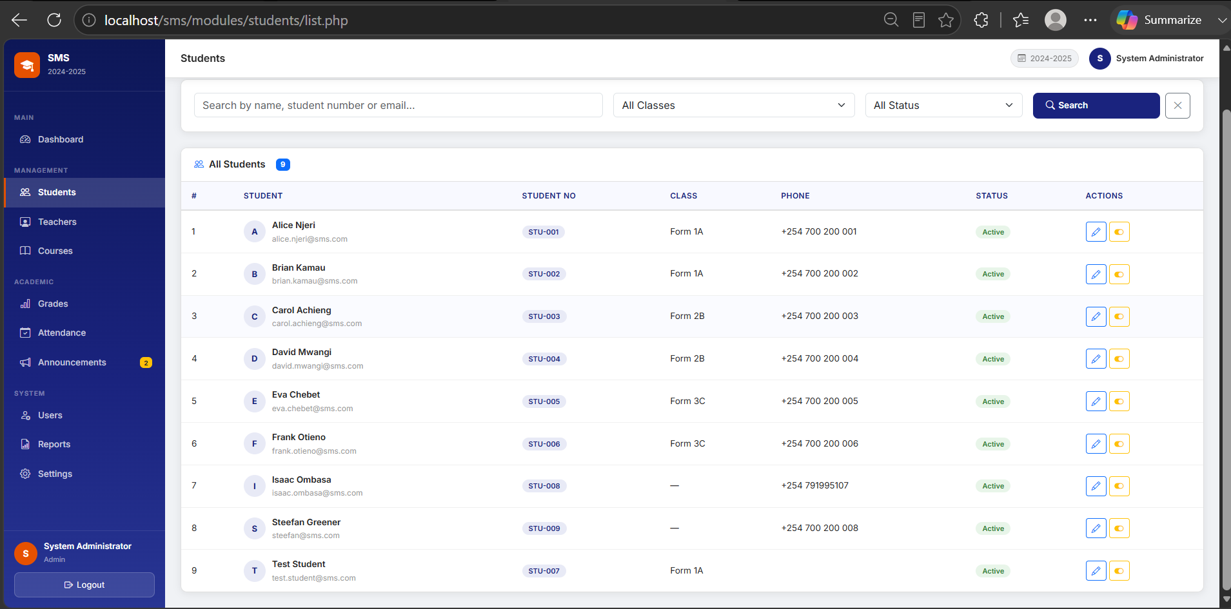

Figure 7: Edit student form pre-populated with existing student data ready for update
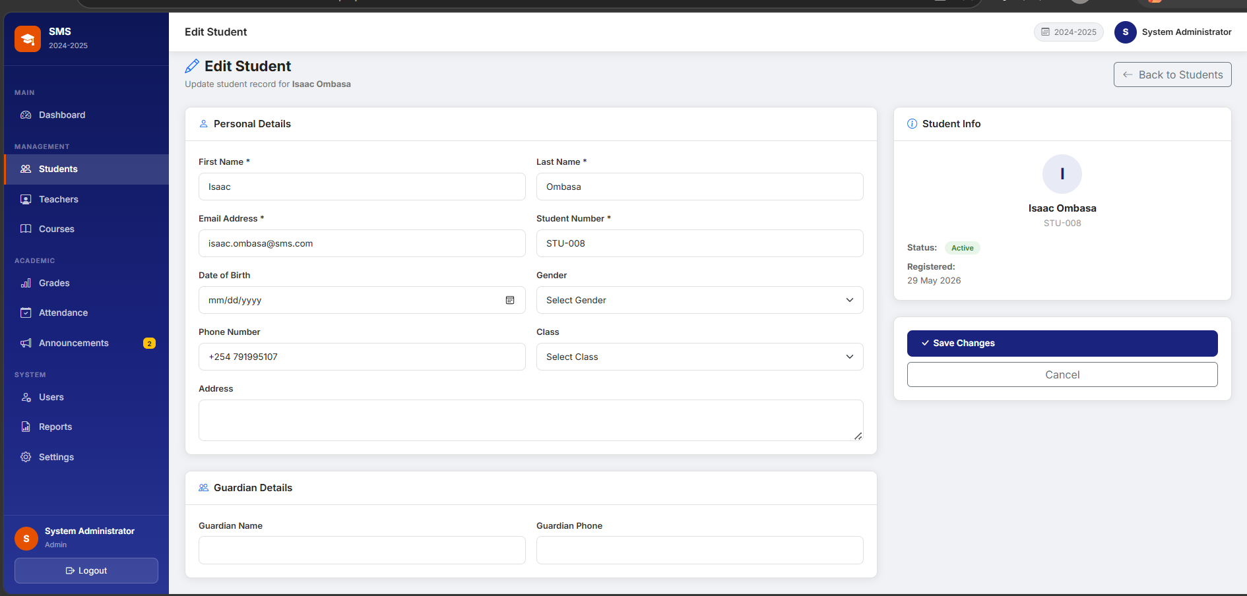

Figure 8: Green flash message confirming the student record was updated in the database
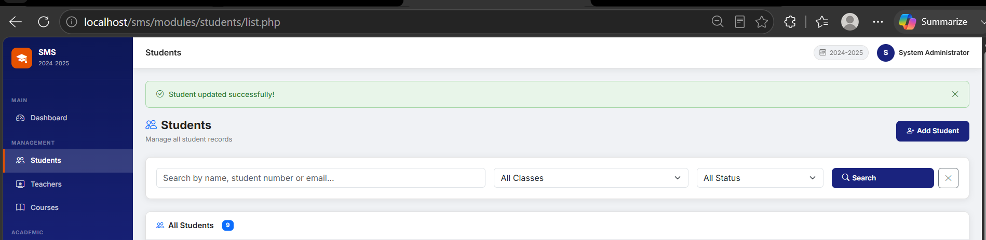

Figure 9: JavaScript confirmation dialog appearing before deactivating a student account
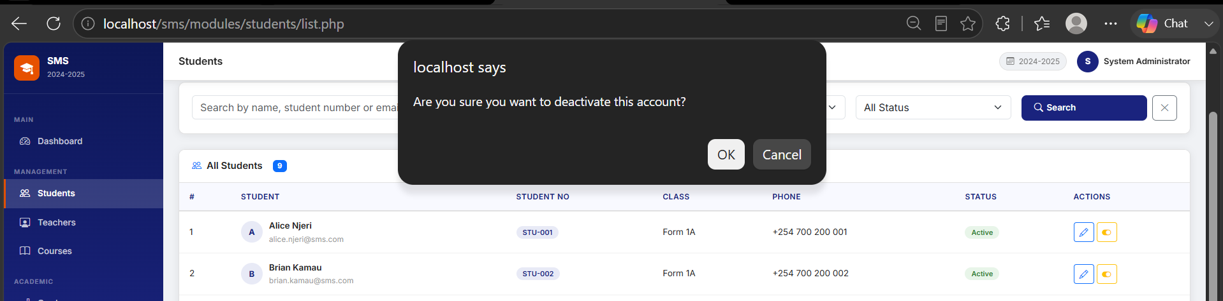
Figure 10: GitHub repository showing Week 6 source code, database script and screenshots uploaded
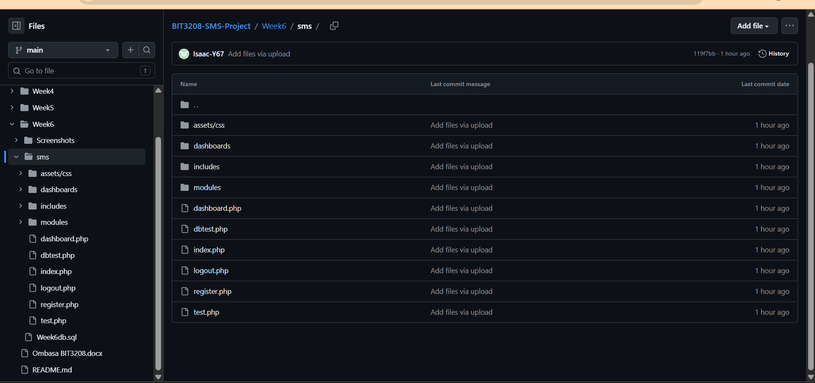

Reflection
This week demonstrated full CRUD operations in the Student Management System using PHP PDO prepared statements, which prevent SQL injection on every database query. The students module uses a database transaction to insert into both the users and students tables together, ensuring both succeed or both roll back. The READ operation uses a JOIN query combining students, users and classes tables to display complete records on one page. UPDATE checks for duplicate emails and student numbers before saving changes, while DELETE uses a soft delete approach that deactivates accounts instead of permanently removing data, preserving historical grades and attendance. The main challenge was understanding why foreign key constraints required inserting parent records like classes before child records like students.

WEEK 7: User Authentication and Session Management

Evidence

Figure 11: Registration page showing full name, email, student number, phone and password fields with strength checker
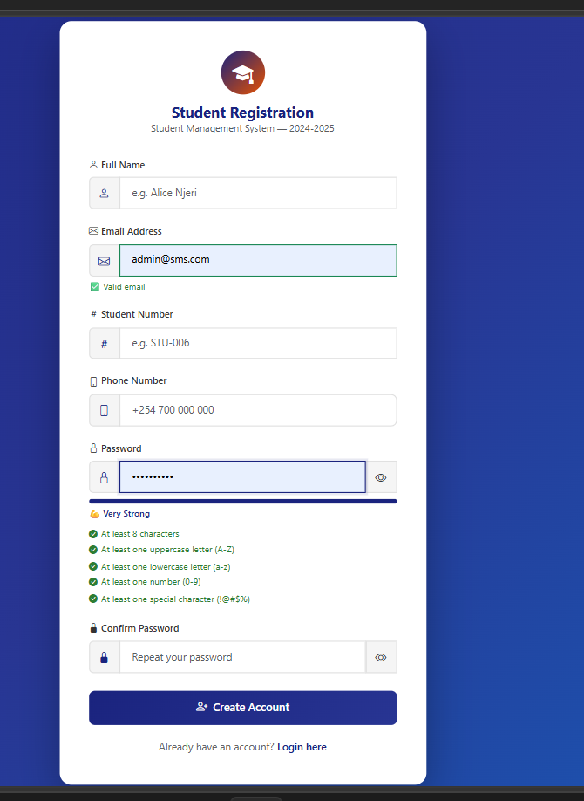

Figure 12: users table Browse tab showing bcrypt hashed passwords confirming passwords are never stored as plain text
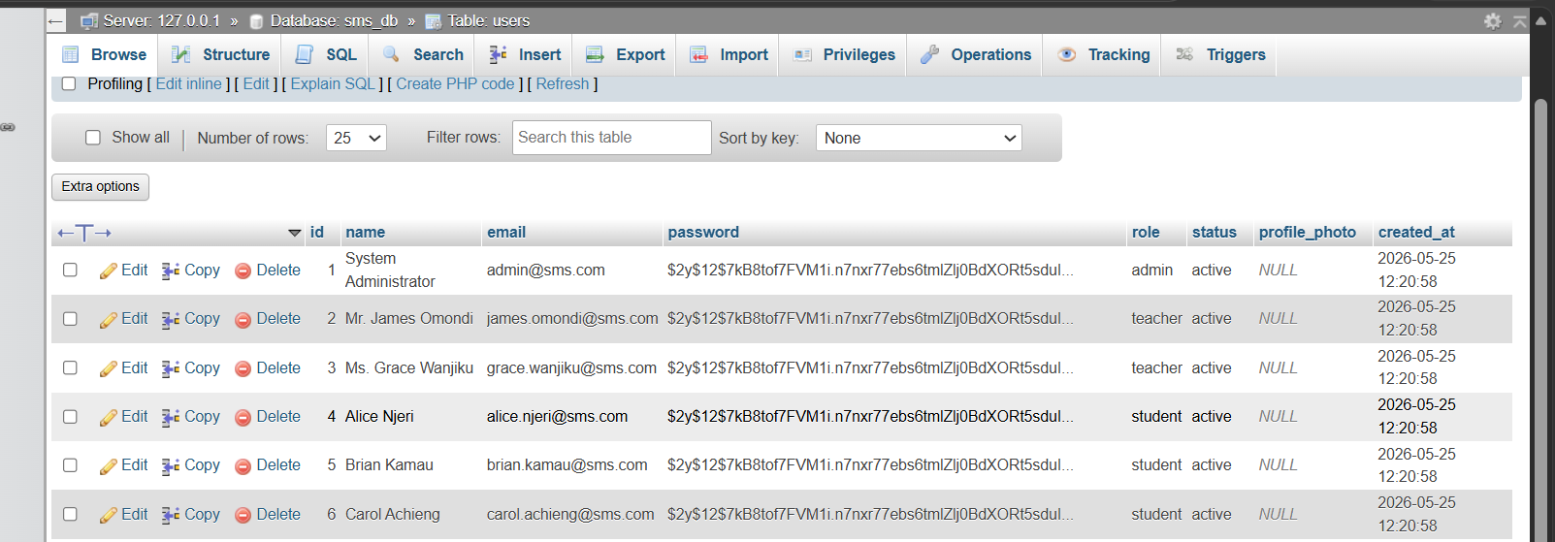

Figure 13: SMS login page showing email field, password field with show/hide toggle and login button
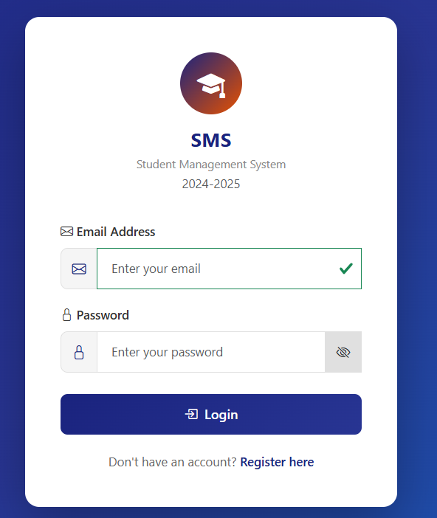

Figure 14: Successful admin login redirecting to admin dashboard confirming session creation
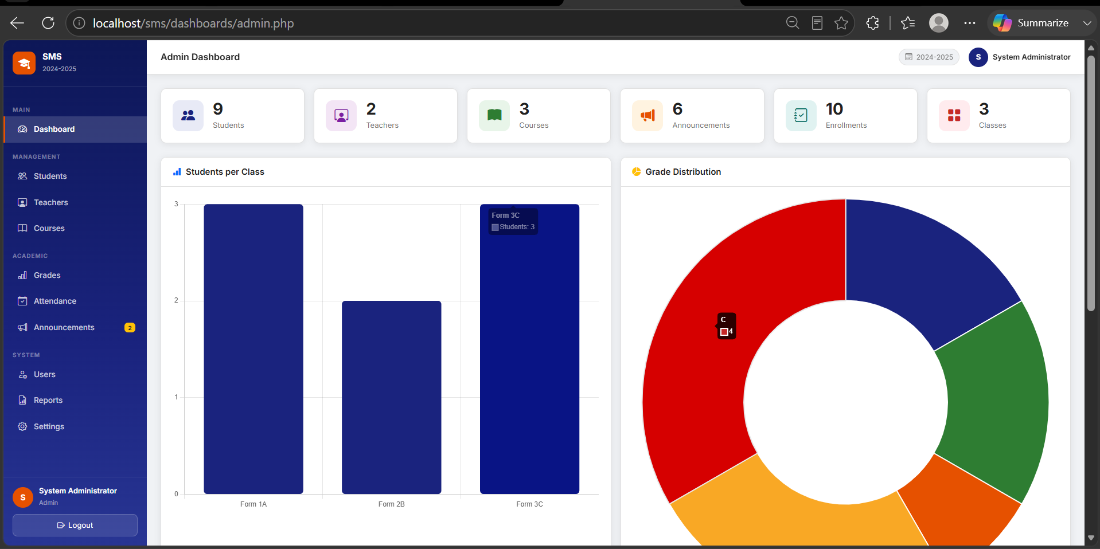

Figure 15: PHP session variables showing user_id, user_name and user_role stored after login
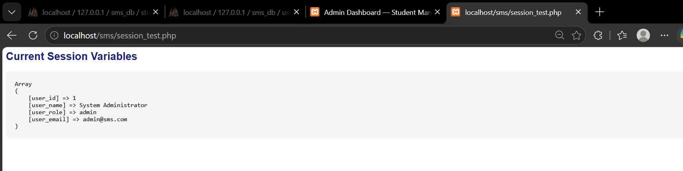
Figure 16: Browser redirected to login page when attempting to access dashboard without being logged in
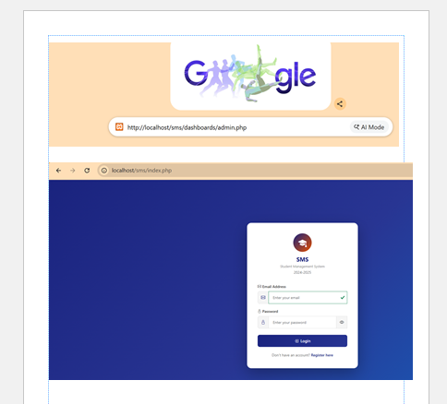
Figure 17: Admin dashboard accessible only to admin role showing sidebar, stat cards and charts
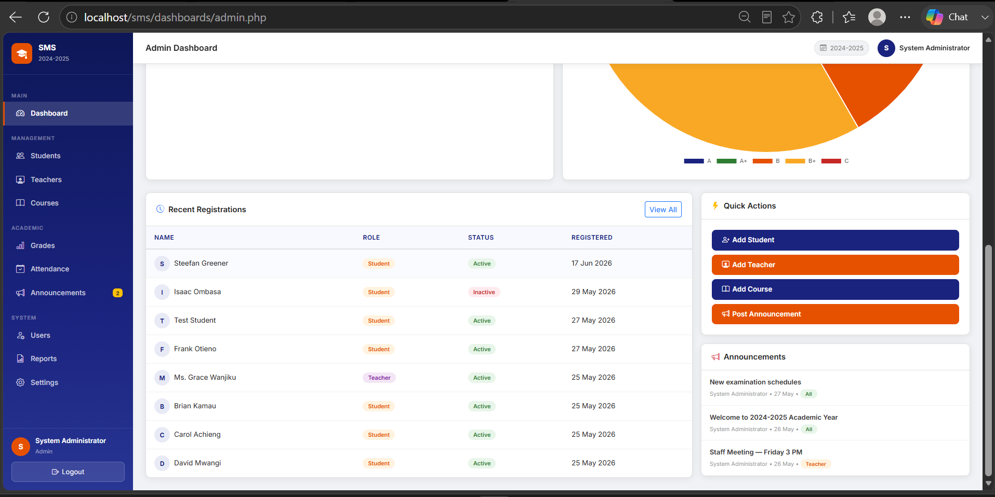

Figure 18: Teacher dashboard accessible only to teacher role showing assigned courses and marks chart
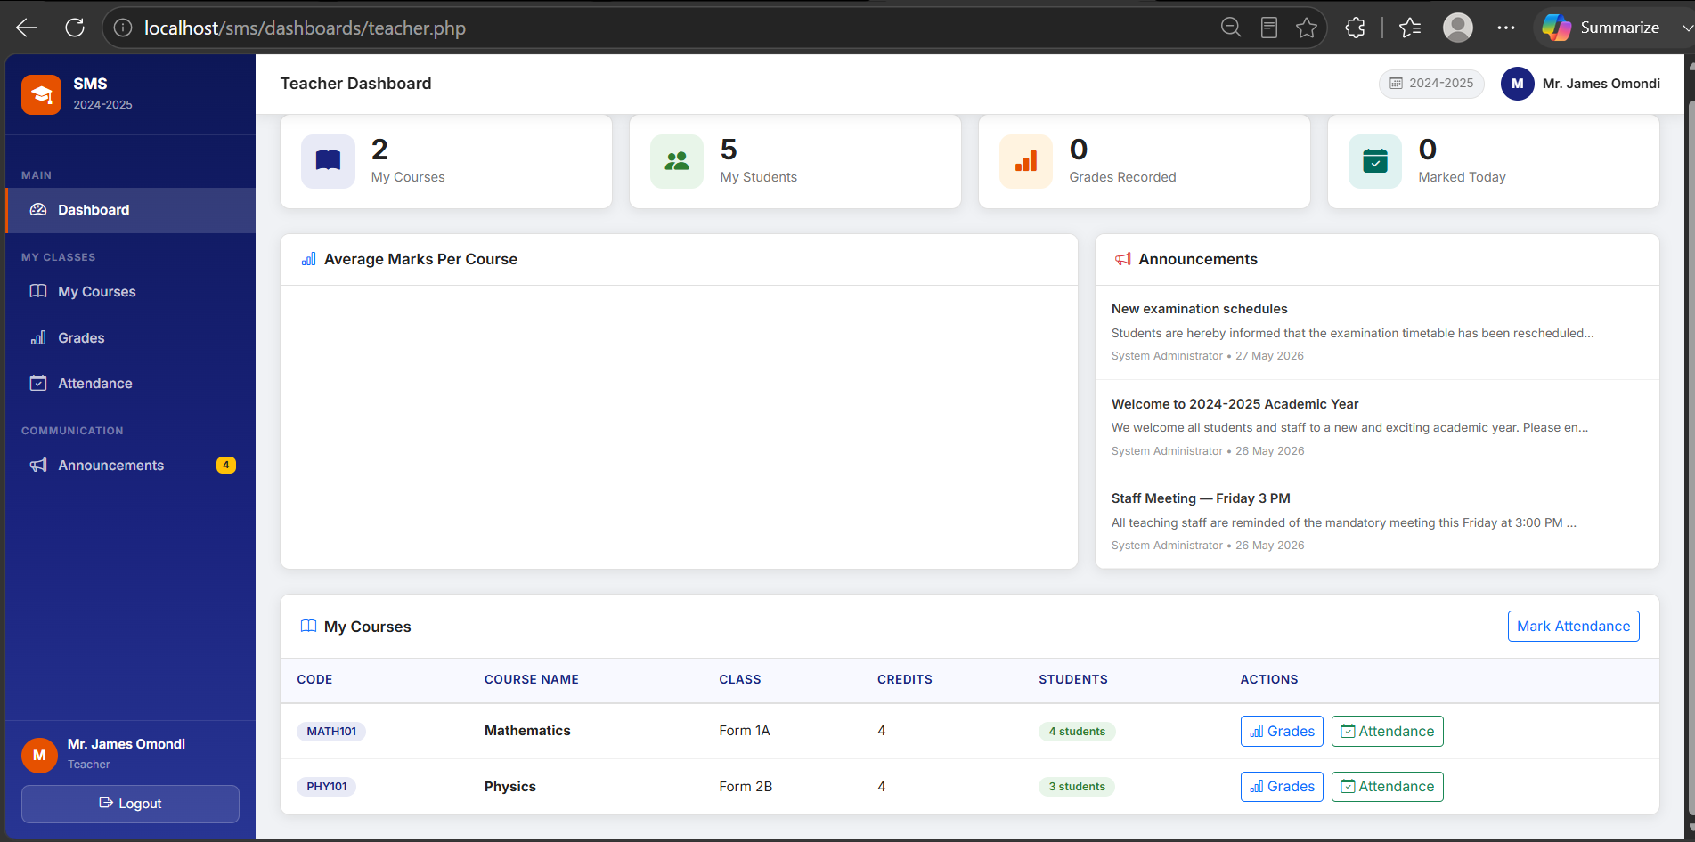

Figure 19: Student dashboard accessible only to student role showing grades and attendance bars
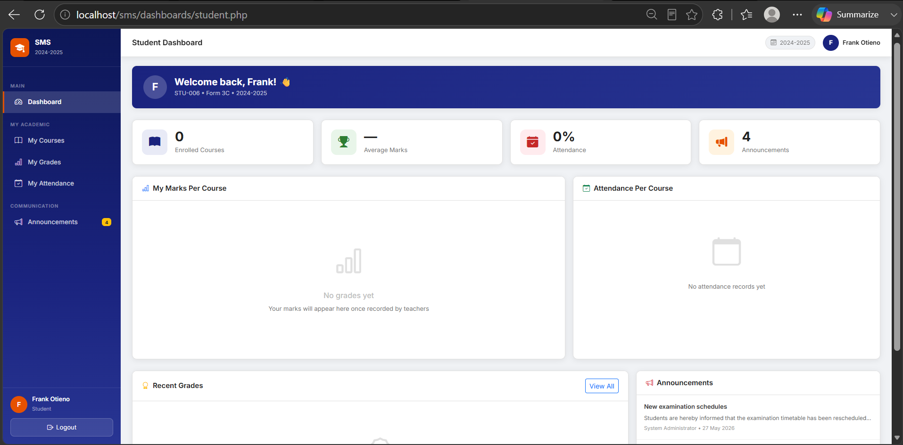

Figure 20: Login page shown after logout confirming the session was destroyed
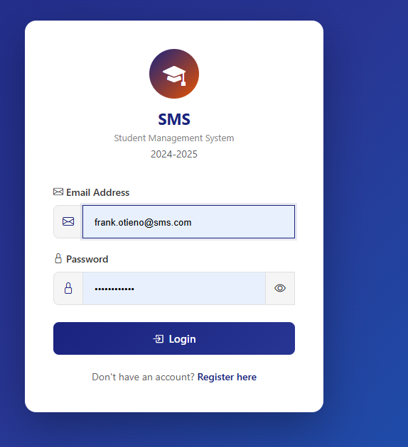

Figure 21: GitHub repository showing Week 7 source code, database script and screenshots uploaded
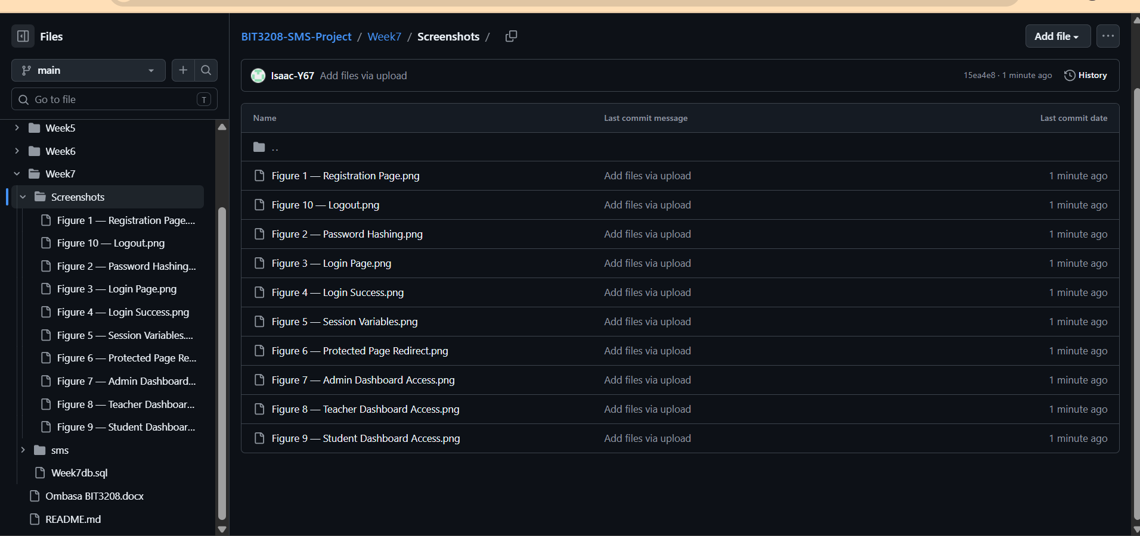

Reflection
This week focused on building a secure authentication system for the Student Management System. Passwords are hashed using PHP's password_hash() function with bcrypt at cost factor 12, meaning even if the database were compromised, actual passwords could never be read. On successful login, session_regenerate_id() is called immediately to prevent session fixation attacks, and the user's id, name and role are stored in $_SESSION for use throughout the system. Every protected page calls requireRole() from auth.php, which checks the session before allowing access and redirects unauthorized users straight back to the login page, as demonstrated in Figure 6. The logout script clears and destroys the session completely. The main challenge was understanding why session_regenerate_id() must be called right after login rather than before, to properly prevent fixation attacks.

